**By Stephen Semmelroth, Founder, Rainier Cyber – A Veteran-focused Recruiting Firm. Sold to StrataCore.**

**General Resume Guidance**

* Utilize the following points. They will help for a number of reasons ranging from making sure an ATS doesn't just drop your resume because it can't read it to making sure junior HR professionals read the right content.
* Technical resumes should be two pages.
* Put the most important section, bullet, or list item first. If a bad recruiter only reads one thing, what do you want them to read?!
* Use the same font throughout.
* [Read this article.](https://www.inc.com/peter-economy/an-executive-reviewed-more-than-480000-resumes-linkedin-profiles-he-found-these-18-stunning-mistakes-you-should-fix-right-now.html) You might not yet trust Rainier Cyber but you certainly can trust Jack Kelly who leads one of the largest talent companies in the world.
* From Laszlo Bock, the former lead talent officer at Google: "When it comes to resumes, Bock says, substance definitely matters more than style. He'd definitely prefer to see a simple, traditional, perfectly formatted resume than something creative that’s tough to read. “Unless you're applying for a job such as a designer or artist, your focus should be on making your resume clean and legible,” he writes." This quote is by [The Muse Editor.](https://www.themuse.com/advice/5-huge-resume-mistakes-googles-head-of-hr-sees-all-the-time)
* Lead is not LED.
* Delete the word/phrases "Responsible for," "proven," and "detail oriented."
* Use the Oxford comma. Oxford commas help readers differentiate between list items. Your resume is a list of lists. You may revert to serial commas for your side gig writing in prose.

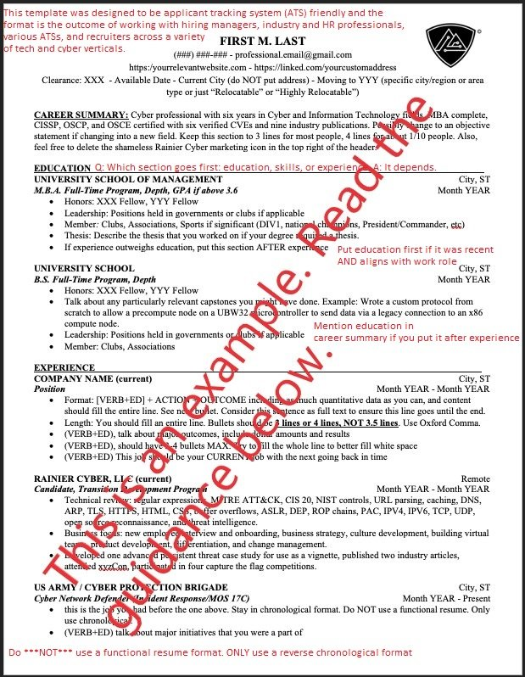

**Resume Writing Tips**

* Header: Do not put your actual address: Just city and state.
* Header: List available date or time frame
* Header: List any clearances
* Header: List how relocatable you are
* Body: Each bullet should be in the VAR format [PAST TENSE VERB] + [ACTION] + [RESULT] and be as quantitative as possible. This is sometimes called an [achievement-based" resume: "Accomplished [X], as measured by [Y], by doing [Z]." in this article by Bill Murphy Jr.](https://www.inc.com/bill-murphy-jr/there-are-3-kinds-of-resumes-top-recruiters-at-companies-like-amazon-google-say-they-only-want-people-who-use-format-number-3.html)
* Body: Each line needs to be a full line: either 3 or 4 lines, NOT 3.5 lines
* Body: Again, put the most important bullet first!
* Body: One-year jobs get at most three bullets. Five-year jobs can have up to six. Write short.
* Body: Timeframe - go back about ten years.
* Body: Avoid columns and tables. Many ATS (applicant tracking systems) will either mangle, or drop, your resume if you use columns and or tables. Seriously. You do not have to believe us on that subject, [go here: https://www.jobscan.co/blog/resume-tables-columns-ats/](https://www.jobscan.co/blog/resume-tables-columns-ats/)

**Audiences to Consider**

**When writing a resume there are four audiences to consider:**

1. Applicant Tracking Systems: A Gatekeeper. You probably hate these. Rightly so. These are the robots that look at your resume and see if you are a fit. Many ATSs have a hard time understanding columns so...avoid columns. See above. They also do not understand what a "Code Ninja" is so please use industry terms like "Senior Developer."
2. **The junior recruiter / reviewer:** A Gatekeeper. This is the HR guy that has been there a couple years and still has no idea about what it is you actually do. He thinks that Sec+ and OSCE are industry equivalents because OSCE is just another industry certification. To really get through to these people, you need to list not just the certification but also the things you learned in the certification. Example: during OSCP you will probably use nmap, Immunity Debugger, Ollydbg, Python, Ruby, and maybe reflective DLL injection so list those things as well.
3. **The senior recruiter:** This lady actually reads your resume and possibly hands it over to the hiring manager. This can be either a company internal recruiter or a recruiting firm, by the way. Hopefully the senior recruiter actually has a technical background or enough time in the industry to understand your daily trials and tribulations and should definitely know the difference between CEH and CISSP.
4. **The Hiring manager.** This lady decides if you get the job and will probably be your boss. Everyone else you talked with prior was just a stumbling block designed to prevent access to her. She can see through your BS. She will probably ask you about everything on your resume. Note: if you list a skill on your resume but have not looked at in a while, grab a beer and a skill cheat sheet and study a bit before she calls you.
5. For more info on the Four Audiences, check out the 2018 Ladder's Resume Guide by Marc Cenedella.